**Supplementary Requirement Release 2**

1. Connectivity

**Scope:**

* UC01.01 Register new customer user
* UC01.02 View Account Details
* UC01.03 User Login
* UC01.04 Admin Login
* UC01.05 Create Admin Account
* UC01.06 Update Admin Account Details
* UC01.07 Update User Account Details
* UC01.08 Reset Password
* UC02.01 Add/Delete Menu Item
* UC02.02 Edit Menu Item Cost/Description
* UC03.01 View Menu
* UC03.03 Add/Remove item(s) to Cart
* UC03.04 View Past Orders
* UC03.05 Reorder Food
* UC03.06 Modify Order
* UC03.07 Display items/total price in cart
* UC03.10 Order received
* UC03.11 Search Menu Item
* UC03.12 Accept/Reject order
* UC03.13 Add to favourites
* UC03.15 Choose pickup time
* UC04.02 Use Rewards
* UC04.03 Accept Rewards
* UC05.01 Add credit/debit card
* UC05.02 Choose Pay online/in person
* UC05.03 Payment Complete
* UC05.04 Validate payment with stripe

Requirements:

* System should retain caches to populate values, if the front-end is disconnected due to Network issue.
* System should also show a popup window with an error message, “Connection failed, please try again later”.
* After the connection has been reestablished, the system has to restore all the prior information entered by the user from the cache.

**Conditions to Apply:** Around the respective join points.

1. Field Validation
   1. “Field Price”

Scope:

* UC02.01 Add/Delete Menu Item

Requirements:

* Field is mandatory and should not be empty
* To add an item, the price field should only contain positive decimal numbers above the number 1 and the “$” symbol.
* Should be no longer than 10 characters long
* System should produce an error message when a negative number or a whole number is inputted
* System should produce an error message if a character other than “.” and “$” is inputted into the textfield
  1. Field “Name”

**Scope:**

* UC02.01 Add/Delete Menu Item

Requirements:

* Field is mandatory and should not be empty
* Should be no longer than 20 characters long

**Conditions to Apply:** After the respective join points.

1. Data Flow Out

**Scope:**

* UC 02.01 Add/Delete Menu Item

Requirements:

* Any item added to the menu or deleted from the menu must be reflected on the customer side of the website
* New item added by admin user, the menu should reflect the new items name and price (as well as description and image if provided)
* When an admin user deletes a menu item, the menu should reflect the deletion automatically.

**Conditions to Apply:** After the respective join points.

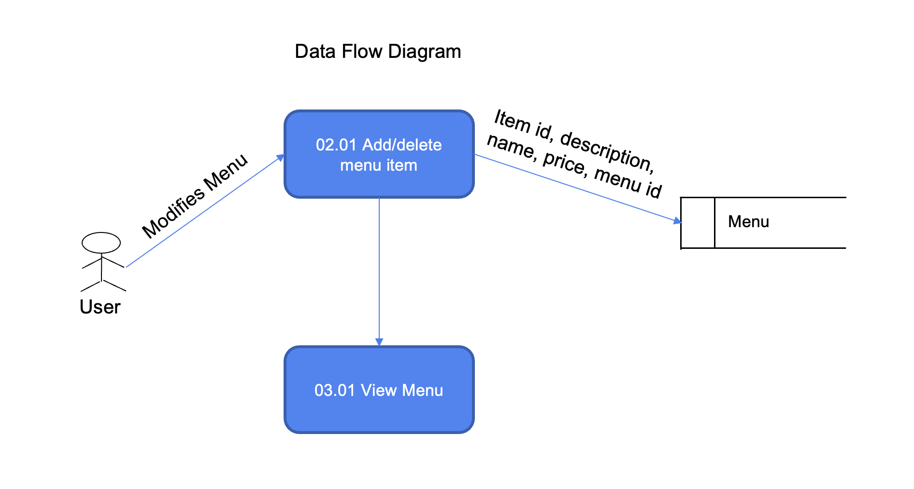

1. Data Flow In

**Scope:**

* UC03.11 Search Menu Item

Requirements:

* Retrieves one or more item names from the menu as a user searches for an item in the menu.

**Conditions to Apply:** Before the respective join points.

